Thread Management using POSIX Library - Detachment and Cancellation assignments

Mandatory

- Write a program to create 3 threads with the detach and cancel status as below.

Thread# | Detached (Y/N) | Cancel type | Cancel status
1 | Y | PTHREAD_CANCEL_DISABLE
2 | N | PTHREAD_CANCEL_ENABLE | PTHREAD_CANCEL_DEFERRED
3 | N | PTHREAD_CANCEL_ENABLE | PTHREAD_CANCEL_ASYNCHRONOUS

- Let all the threads read and display their detach, cancel type and status and then display thread specific message as below.
T1: Display message in the format as below every 2 secs
<timestamp> Health OK
T2: Print numbers starting from 1000 in steps of 2 at an interval of 3 secs in format as below.
<timestamp> <threadid> <countvalue>

T3: Print numbers starting from 2000 in steps of 2 at an interval of 3 secs
<timestamp> <threadid> < countvalue >
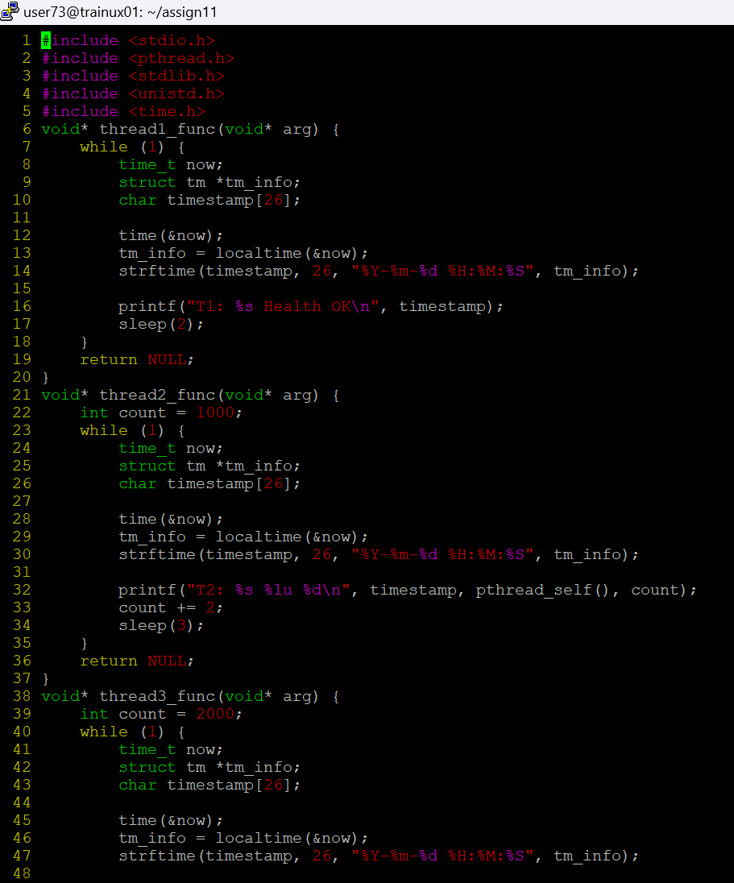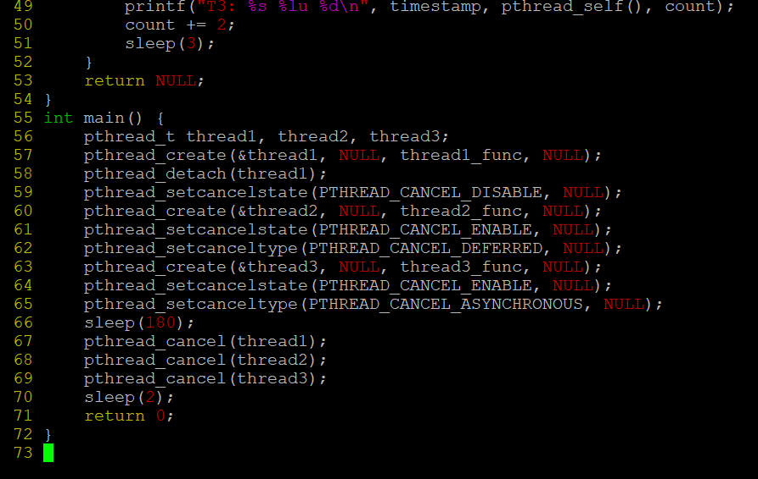

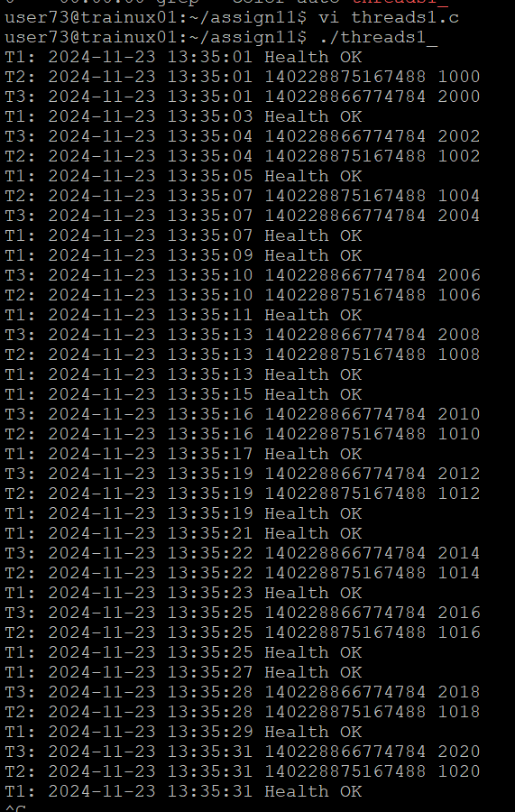
- After creating threads, and after 3 minutes from main(), cancel all 3 threads
- From an other terminal, use command below to view the thread count of your program
    - ps -eLF
    - top
[For top command usage to refer https://www.golinuxcloud.com/check-threads-per-process-count-processes/ ]

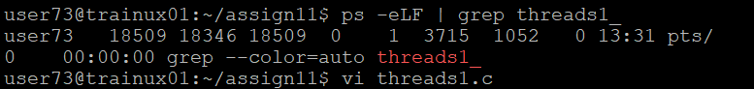
- What difference did you observe between top and ps command?
- The top command provides a real-time, dynamic view of system processes and resource usage, updating continuously, while the ps command gives a static snapshot of processes at a specific moment.
- top is interactive, allowing real-time sorting and process management, whereas ps is non-interactive and outputs once.
- top can show threads with the H key, while ps requires the -L flag to display threads.
- Which column shows the number of threads in ps and in top commands?
- In the top command, the number of threads is displayed in the "TH" (Threads) column.
- In the ps command, when using ps -eLf, the number of threads is shown in the "NLWP" (Number of Light Weight Processes) column.
- Additionally, each thread's ID is shown in the "LWP" column in ps.

- Check the last message timestamp from the threads
- To check the last message timestamp from the threads, you can use top or ps with appropriate options to display thread activity.
- In top, press H to show threads and observe the "TIME" or "CPU time" column for the last activity.
- In ps, use ps -eLf to list threads and check the last activity timestamp in the "TIME" column.

- Which thread was cancelled first and why?
- The thread with PTHREAD_CANCEL_ASYNCHRONOUS was canceled first. This type of cancellation is immediate, meaning the thread is canceled as soon as the cancel request is made.
- In contrast, threads with PTHREAD_CANCEL_DEFERRED or PTHREAD_CANCEL_DISABLE will be canceled later or not at all until explicitly handled.

- Were all 3 threads cancelled? Justify the observation
Not all three threads were canceled. The thread with PTHREAD_CANCEL_DISABLE was not canceled because cancellation was disabled for it. The other two threads were canceled based on their respective cancellation types: PTHREAD_CANCEL_DEFERRED (canceled when it reaches a cancellation point) and PTHREAD_CANCEL_ASYNCHRONOUS (canceled immediately).

